
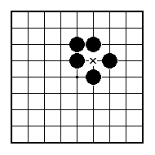
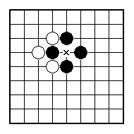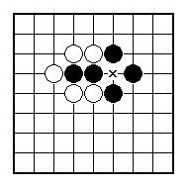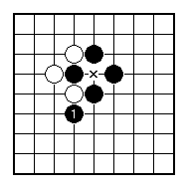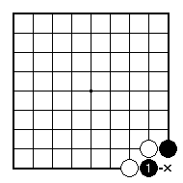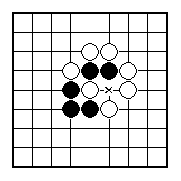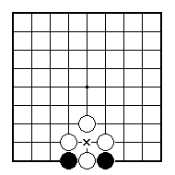
If White plays at x, is Black allowed to recapture right away?

If White plays at x, is Black allowed to recapture right away?

Black just played the stone marked 1.
Can White play at x?

Black just played the stone marked 1 capturing a white stone. Can White play at x?

Is Black plays at x, is White allowed to recapture right away?

Is Black plays at x, is White allowed to recapture right away?

NAME:
BRITISH GO ASSOCIATION CERTIFICATE LEVEL 2 - SHEET 2

THE KO RULE

